Portfolio Site Notes
Tech Stack Explained

Overview
This project is built with:
- Vite
- TypeScript
- React
- shadcn-ui
- Tailwind CSS (COVER MANUAL INSTALL AS WELL SOON!!)
(https://ui.shadcn.com/docs/installation/manual)

Core Framework:
- React 18 - Modern component-based UI library
- TypeScript - Type-safe JavaScript for better development experience
- Vite - Lightning-fast build tool and dev server

Styling & Design:
- Tailwind CSS - Utility-first CSS framework for rapid styling
- shadcn/ui - High-quality, accessible component library
- Custom Design System - Semantic tokens in index.css and tailwind.config.ts (cover custom design system)
State & Routing:
- React Router DOM - Client-side routing
- TanStack Query - Server state management (ready for API integration)
Icons & Fonts:
- Lucide React - Beautiful, consistent icon library
- Google Fonts - Inter (display) and JetBrains Mono (code)

🎨 Design Features:
- Dark Terminal Theme - Deep blacks with cyan/purple accents
- Responsive Design - Mobile-first approach
- Glassmorphism Effects - Subtle transparency and blur
- Smooth Animations - Custom keyframes and transitions
- Gradient Text - Animated color gradients
- Glow Effects - Subtle lighting for interactive elements

📁 Modular Architecture:
Each component is completely independent and reusable:

Navigation.tsx - Responsive nav with smooth scrolling
Hero.tsx - Animated typing effect and call-to-actions
About.tsx - Personal story with stats cards
Skills.tsx - Categorized skills with progress bars
Projects.tsx - Filterable project showcase
Contact.tsx - Contact form with social links
Footer.tsx - Clean footer with tech stack info

✨ Animation Ready:
- CSS custom properties for easy customization
- Pre-built animation classes (animate-float, gradient-text, etc.)
- Smooth transitions using custom timing functions
- Space for adding Framer Motion, GSAP, or other librarie
Framer Motion – React & JavaScript animation library [FOCUS ON REACT]
GSAP – (not yet important for you)

<You can now customize colors, add your projects, and expand with additional animations!
What's next?
- Refine & Customize: Update personal information, project details, and contact info
- Add Backend Features: Connect to Supabase for contact form submissions, blog posts, or analytics
>

DOCUMENTATION SECTION

🚀 Self-Deployment Guide
Prerequisites:
# Install Node.js (version 18 or higher)
# Download from: https://nodejs.org/

# Verify installation
node --version
npm --version

Deployment Steps
  - Clone/Download project
# If connected to GitHub
git clone <your-repo-url>
cd <your-project-name>

# Install dependencies
npm install

# Test locally
npm run dev

  - Build for Production
# Create optimized build
npm run build

# Preview production build locally
npm run preview# Create optimized build
npm run build

# Preview production build locally
npm run preview

  - Deploy Options (use own server)

🏗️ Project Architecture

File Structure
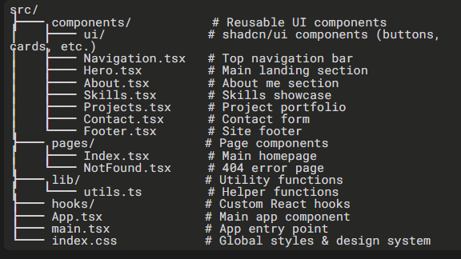

⚡ Tech Stack Explained
Core Framework
React 18: JavaScript library for building user interfaces
TypeScript: Adds type safety to JavaScript
Vite: Super fast build tool and development server
Styling System
Tailwind CSS: Utility-first CSS framework
Custom Design System: Defined in index.css and tailwind.config.ts
CSS Variables: For consistent theming and dark mode
UI Components
shadcn/ui: Pre-built, customizable components
Radix UI: Accessible component primitives
Lucide React: Beautiful icon library
Routing & State
React Router: Client-side routing
TanStack Query: Data fetching and caching

